**Problem Statement :**

In the process of designing an efficient IoT system, competent filter design is an essential step that ensures smooth interaction between devices that make up the network. Looking at the IoT spec we see that we will be transmitting eight Frequency-Division Multiplexed signals that each occupy 180KHz with a separation of 20KHz between each frequency band. With this in mind, and the importance of accurate signal transmission in such applications as IoT, we can see that we will need a filter with a slim transition region, strong stopband attenuation, and minimal passband ripples and passband attenuation. These constraints are inversely proportional with another constraint in our design process; the filter order, which we aim to minimize so that the filtering process is not computationally complex, thus risking our filter to be costly and slow when implemented as hardware. Therefore, our aim is to find the most reasonable compromise that can ensure efficient, and accurate signal transmission.

**Design Constraints:**

**Passband and Stopband attenuation:**

Seeing as each signal’s frequency span ends at 90KHz, and the end of the separation band is at 110KHz, The Passband attenuation will have to not exceed 3dB (0 to 90 KHz), and the stopband attenuation will have to be at 20dB or more (110 KHz or more) to ensure no interference between two subsequent bands occurs.

**Transition Region:**

As is specified in the format 1 transmission spec, the spacing between the center frequencies of each two subsequent uplink signals is 200 KHz. With this in mind, and the fact that each signal takes up 180KHz, we are left with the constraint of the transition region being no wider than 25KHz, having attenuation of at least 15 dB at the 20KHz mark of the transition region. This is essential to avoid interference and distortion of transmission data.

**Filter Order:**

Even though a higher-order filter resembles an ideal filter more closely than a lower order filter, higher filter orders correspond to more multiplications and therefore pose a computational load that will hinder the performance of the entire system. Consequently, we need to minimize the filter order to a point where the other constraints are not violated to ensure the efficacy of our solution. We

**Filter Prototypes and Design Iterations:**

**Filter 1:**

Filter design method: **Least squares**

Specs:

Order = 256

Δp = 0.0335, passband ripples= 0.3 dB

Δs = 0.0865, stopband attenuation= - 29.5 dB

Transition band = 0.0216 MHz

This filter is a competent contender due to its low passband ripples, high stopband attenuation, low passband attenuation and small transition band that are all within the specified constraints. The order is somewhat high, nonetheless.

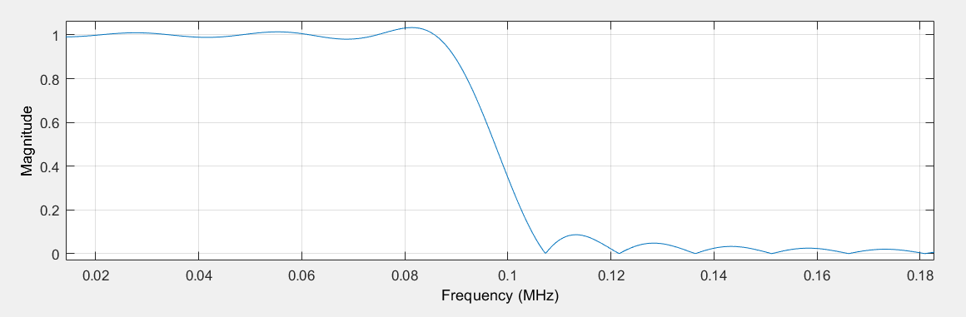

**Filter 2:**

Filter design method: **Least squares**

Specs:

Order=132

Δp = 0.0433, passband ripples= 0.38 dB

Δs = 0.1355, stopband attenuation= - 17.36 dB

Transition band = 0.0354 MHz

This filter will not fit our use case due to its large transition band. The stopband attenuation and passband ripples are within our specified constraints, and the order of the filter is the previous filter.

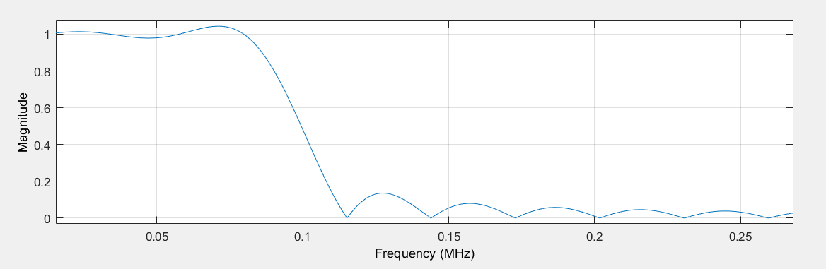

**Filter 3:**

Filter design method: **Equiripple**

Specs:

Order=196

Δp = 0.0254, passband ripples= 0.22 dB

Δs = 0.254, stopband attenuation= - 11.9 dB

Transition band = 0.0209 MHz

This filter has a small transition region, respectable passband attenuation and minimal passband ripples. However, stopband attenuation is subpar, and the order is not as good as other contenders.

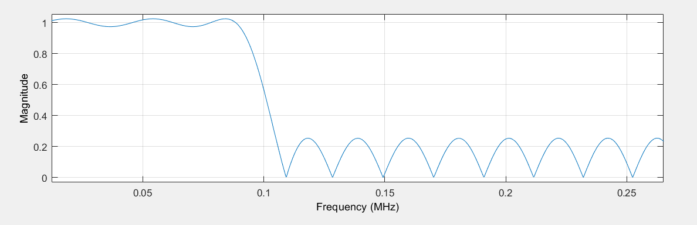

**Filter 4:**  
Filter design method: **Kaiser**

Specs:

Order = 226

Δp = 0.0853, passband ripples= 0.77 dB

Δs = 0.0537, stopband attenuation= - 25.4 dB

Transition band = 0.0234 MHz

This filter has a small transition region, high stopband attenuation, and minimal passband ripples. The order is somewhat high and passband attenuation is high, nonetheless.

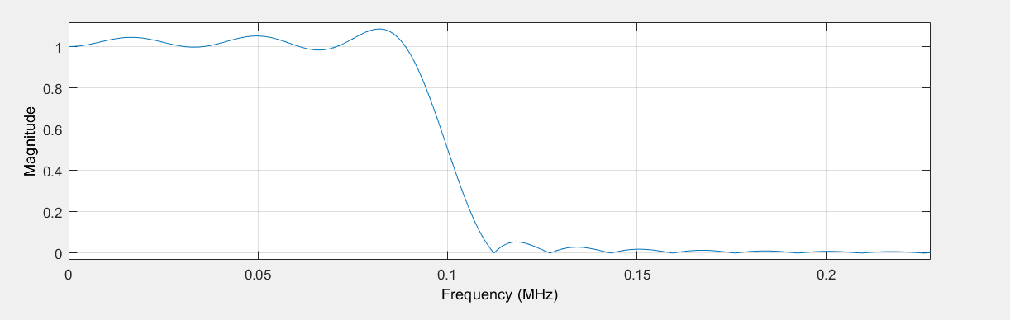

**Filter 5:**

Filter design method: **Kaiser**

Specs:

Order = 181

Δp = 0.0422, passband ripples= 0.3745 dB

Δs = 0.061, stopband attenuation= - 24.3 dB

Transition band = 0.0305 MHz

This filter has low passband attenuation, minimal passband ripples, high stopband attenuation and a reasonable filter order. The transition band violates the constraints we set, however.

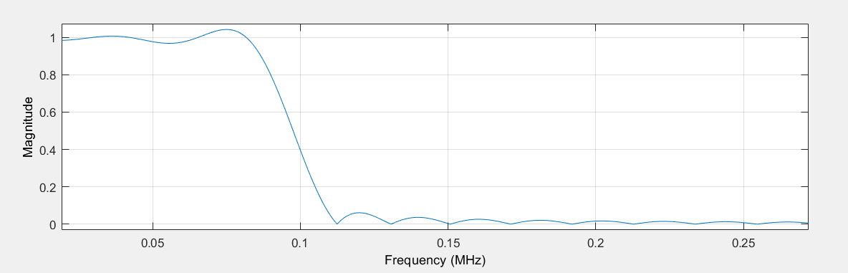

The 226 Kaiser filter is the closest to being our desired optimal filter bounded by the constraints we set, followed by the 256 Least squares filter, which was only disqualified due to its higher complexity that was accompanied by diminishing returns when it came to improvements over the 226 Kaiser.